Jacob Blazina

CS 325

Dr. Salter

April 29, 2021

Cover Letter Research

Screenshot

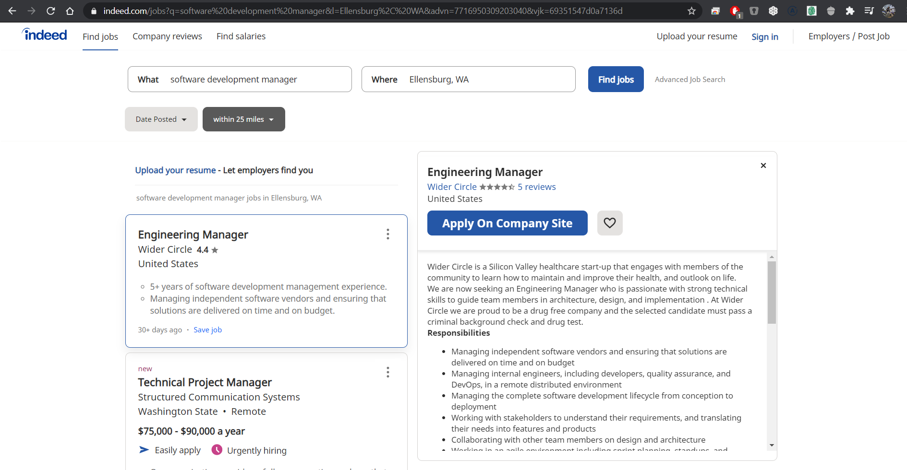

Url

<https://www.indeed.com/jobs?q=software%20development%20manager&l=Ellensburg%2C%20WA&advn=7716950309203040&vjk=69351547d0a7136d>

Company Research

|  |  |
| --- | --- |
| What they do | Healthcare startup. They connect people in local communities to provide social experiences and aid in healthcare. |
| Current Staff | Small company with around 6 main employees. The CEO is Moshe Pinto and the president is Darin Buxbaum. |
| Locations | Located in southern California primarily, with a satellite foothold in Michigan. |
| Customers | Mostly the elder community. |
|  |  |